[Art review for BP Portrait Award Exhibition]
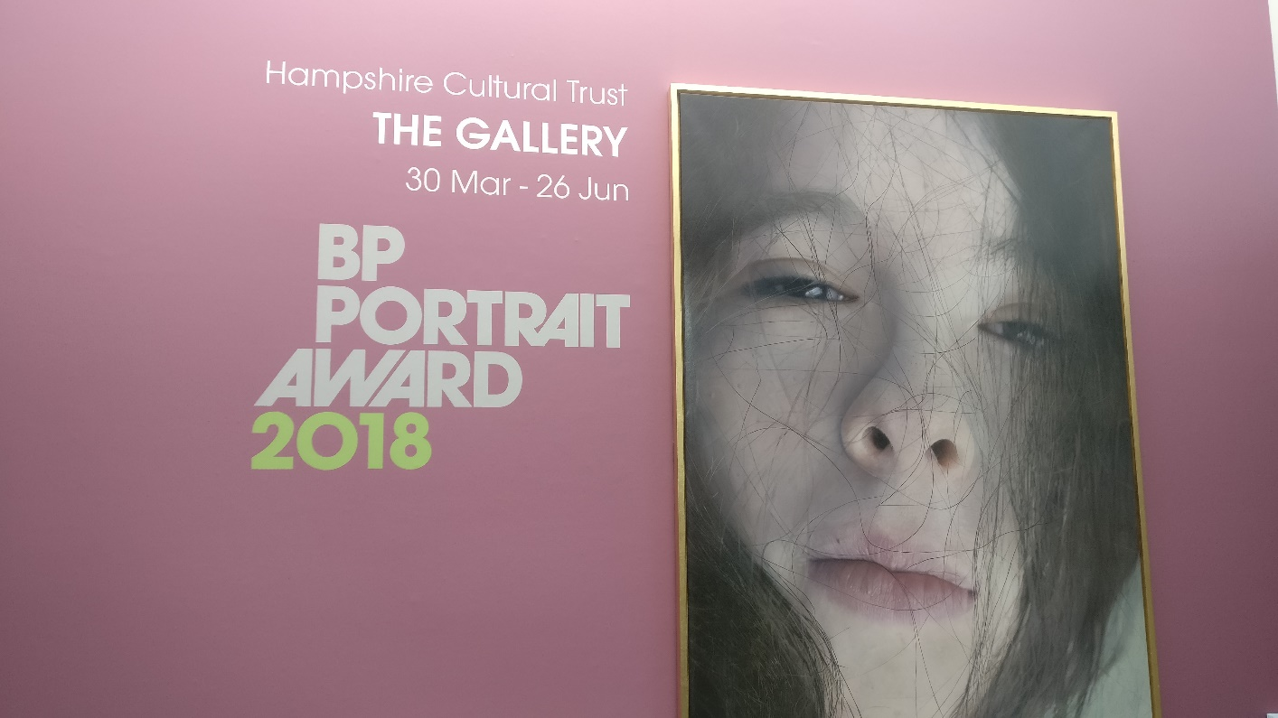
Striking BP Portrait Exhibition Captures the Essence of Humanity – at the Winchester Discovery Centre

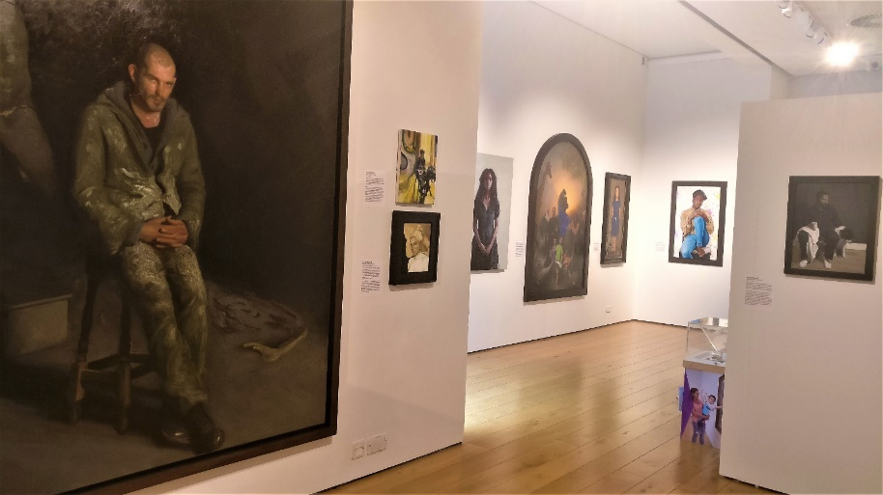
Recently I had the pleasure of visiting the incredible BP Portrait Award 2018 exhibition. After its time at the National Portrait Gallery last year, this collection of 48 remarkable paintings has been on display at the Winchester Discovery Centre, in the Gallery Space, since 30th March. It’s on until 26th June – so you’ll want to go and see it before it disappears.
What I found most striking is how each painting portrays humanity, sharing a glimpse of vulnerability with the viewer on a personal level. A range of ages, races and personalities gaze out from each canvas; some with disabilities, mental health struggles and illness; others exuding passion and confidence as they stand up for what they represent. Many explore subjects in different emotional states, sometimes putting them in settings that build a picture of their personality, such as places of work and creativity. For me, some of the paintings stood out at the time, while others emerged later on. You may find that a few have an atmosphere of ambiguity, perhaps implying something mysterious beneath the surface…
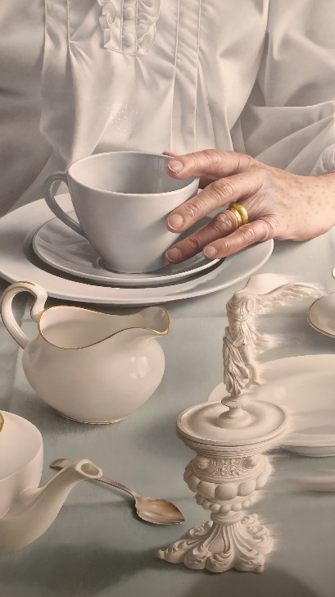
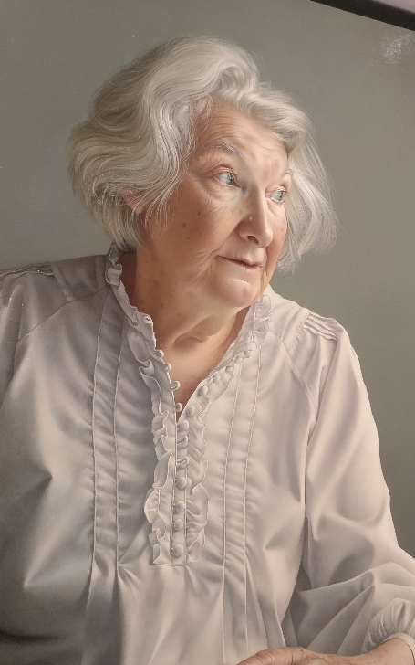
Miriam Escofet’s winning portrait has the quality of a photograph, but is more moving due to Escofet’s careful brushstrokes and earnest portrayal of her mother. Even after looking carefully at this portrait many times, it wasn’t until recently that I noticed some supernatural abnormalities that give it an edge – as you will see from examining the piece.
These deeper layers of detail create a further connection with us, as we discover more within than those who just take the painting at face value. We begin to question why Escofet’s mother is wearing a nightdress… and why there’s no food on the plates, or tea in the teacups. It feels like an echo, a memory in which we have been placed, becoming part of the scene. I wonder what you’ll spot in the painting that I haven’t…

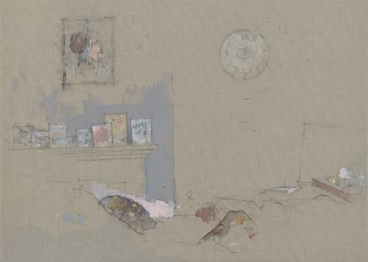
Another piece that stood out to me was Dad’s Last Day by Nathan Ford. While it looks almost like a child’s drawing, this is actually what makes it so poignant. ‘Get well soon’ cards line the mantelpiece, and a clock with a scribble instead of hands shows time becoming non-existent. Ford’s father is reduced to a few lines and shadows, giving a visceral depiction of his suffering while the rest of the room fades away with him. It’s incredible how such emotion can be evoked from so few lines carefully sketched on a small page.
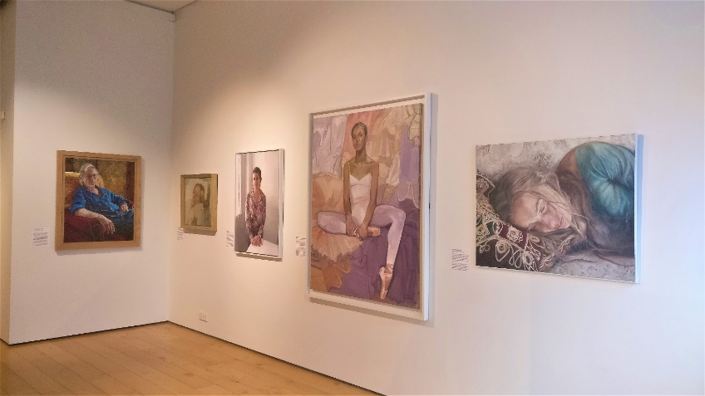
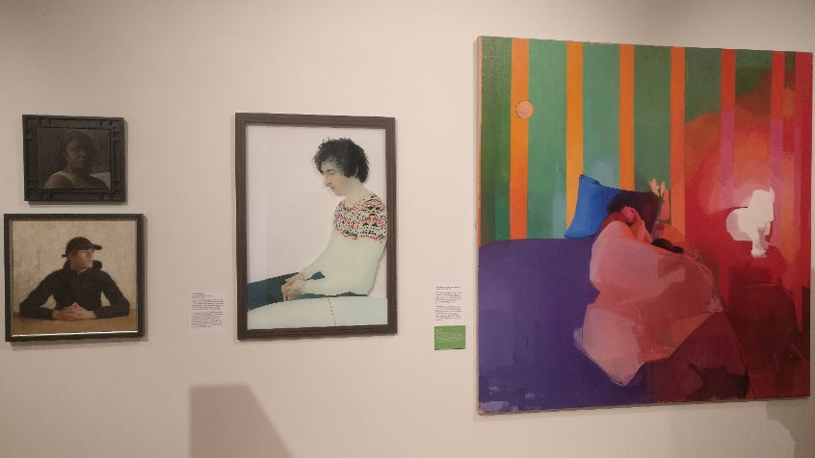
Visit the Discovery Centre in Winchester to meet the subjects for yourself, and discover your own reflections within them that you may never have considered before. See what your take is on the ambiguous messages of some of the paintings, and delve into the mysteries buried under the surface. This striking exhibition will leave a lasting impression, demonstrating art’s ability to impact our lives as it creates a strong, seamless link between artist, subject and viewer. It is less a glorified celebration of humanity than a bold portrayal of its core – and most of all, what it means to be human.

[ICE Project Celebration 2019 + comparison to BP Portrait Award 2019]
Inspirational ICE Project exhibition reflects mature themes of BP Portrait Award…
Downstairs in the Discovery centre, the City Room displayed Alternative Portraiture artwork created by young people for the ICE Project Celebration 2019. Some were bright and bold, with white squares and circles arranged with colourful materials and covered with paint. Others were dark and subtle, inspired by political themes or personal experiences. These were personal portraits that each child created as a depiction of themselves. While many were abstract and unusual, a sense of individuality shone through each piece. Whether they were literally representing their eyes and hearts, or displaying their inner emotions and thoughts, each piece was unique and filled with their own personality.
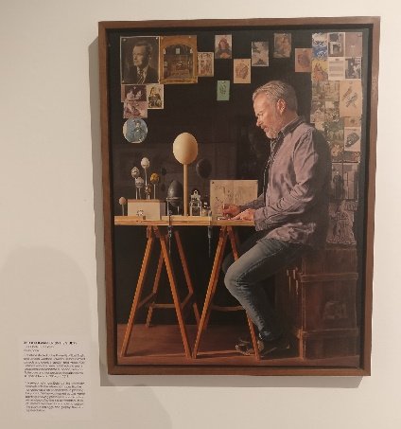
As I walked around the exhibition, I read the attached labels with each piece, written by the young artists. Each had a different take on the task, but all of them shared a passion for the chance to express themselves through art, and use different mediums to create something to represent who they are. This emphasised the beauty of bringing people together to explore their own creativity, as the ICE project has.
While it is a very different exhibition to the BP Portrait Award (upstairs in the Discovery centre), I did notice many similarities. The way in which the children depicted themselves was very honest, as they added their interests, memories and traits into their work. This reminded me of one of the BP Portrait exhibition paintings, The Oolographer (in his study) by J.J. Delvine. A self-portrait of Delvine at his desk, it shows various items that are personal to him – such as eggs that he is going to paint, and many pictures of old masters’ paintings stuck around him on the wall. These give a further impression of his character and interests, extending beyond the subject himself. The subtle dark reflection in the wall demonstrates not only his painting skill and attention to detail, but emphasises the literal reflection of himself that he has created by painting a self-portrait.
Some children’s work in the ICE Project exhibition showed dark representations, of emotional experiences and their inner worries and fears. This is similar to the way Jamie Coreth’s painting in the BP exhibition, Broken Bodies, depicts the dark emotional trauma of a soldier. As he sits in the dark, an eerie cracked sculpture of a man rises up behind him, perhaps representing the PTSD and haunting memories he has been left with.
There is something particularly stirring in the way that such mature themes have been presented by the young children, making them accessible to all age-groups whilst also being ambiguous for people to have their own personal response. One of the young artists was at the exhibition, talking enthusiastically about her work to a few adults, and explaining the process. It was a joy to see how the project inspired such a positive atmosphere from both the young people and those viewing the exhibition, highlighting again how important art can be, for everyone.

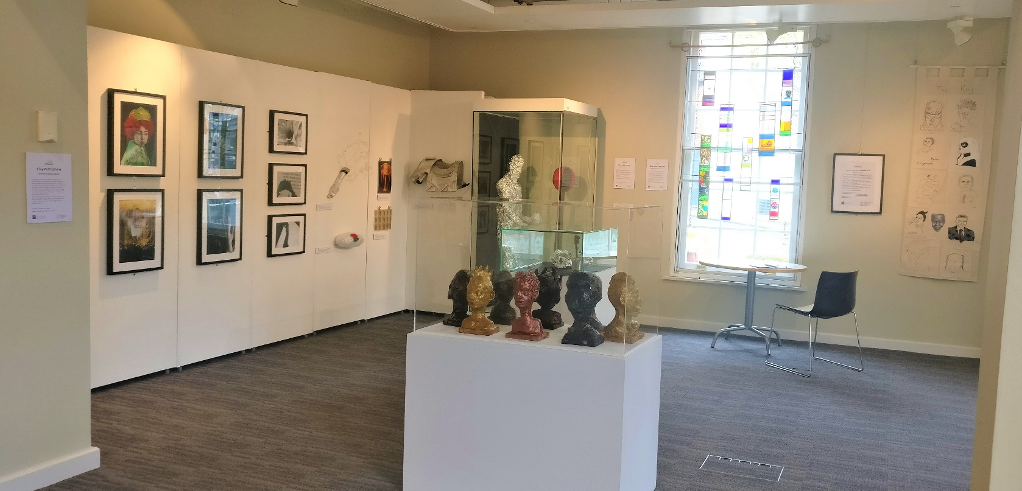
Insightful Horizon 20:20 Exhibition presents personality and self-reflection

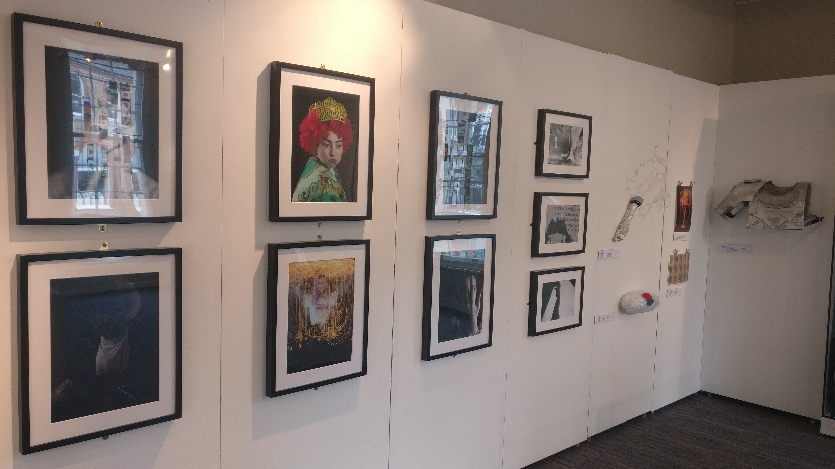
From the 27th April, the Horizon 20:20 exhibition was put on display in the City room, in place of the ICE Project artwork. Incorporating similar themes of identity, personality and inner thoughts, it is on until 15th May. The young artists have created representations of themselves, combining their hobbies and interests through an abstract depiction of themselves. Some striking clay heads in the centre of the exhibition were made by young people from Greenwood School, who worked with artist Kezia Hoffman to create their own personalised sculptures.
Bold and colourful photo compositions line the wall, showing experimentation with different concepts and angles. These demonstrate the young people’s artistic flair and eye for effective composition, as they evoke ideas of complex emotion and vivid imagination. In the corner, a large tin-foil figure stands boxing. With an air of determination, it exhibits a surprising feel of human movement through its form, despite lacking many human features. This represents the young artist’s passion for boxing, and effort to present the feel and atmosphere through form, rather than literal resemblance.
In another innovative piece, Reggie’s Microphone and Lyrics displays a tin foil microphone with his hand-print holding it, and lyrics written with a glue gun. This reflects his enjoyment of rap music and conveys a sense that the meaning is personal to him, as some letters are discernible to viewers but as a whole are incomprehensible.
Portraits sewn with thread hang on the far wall, outlining faces with various colours and harsh lines, yet somehow still exuding a sense of emotion behind each face. Again, this way of creating a feeling through form and vague representation is highly effective, demonstrating that art does not have to be photorealistic to represent the intended subject well.
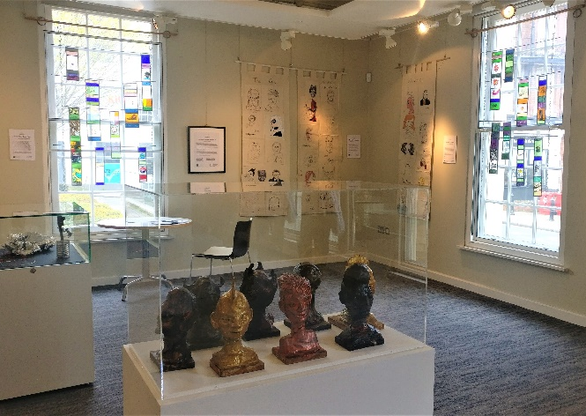
I found that within each piece, and in the exhibition as a whole, there was a real sense of care and attention from the young people. It was as if they had really connected with their artwork and imbued it with their personality, which was therefore reflected through it. Yet, the message each individual viewer sees in the artwork is in fact a reflection of their personality. Therefore, the combination of both personalities creates an atmosphere of human connection and understanding, but still leaves a sense of mystery. This ambiguity lingers, as the original meaning remains in the knowledge of the young artist, as a part of their identity. It is inspiring to see such talent and expression, through the medium of art, from young people discovering their interests and aspects of their personality that they are passionate about and willing to share with the world.
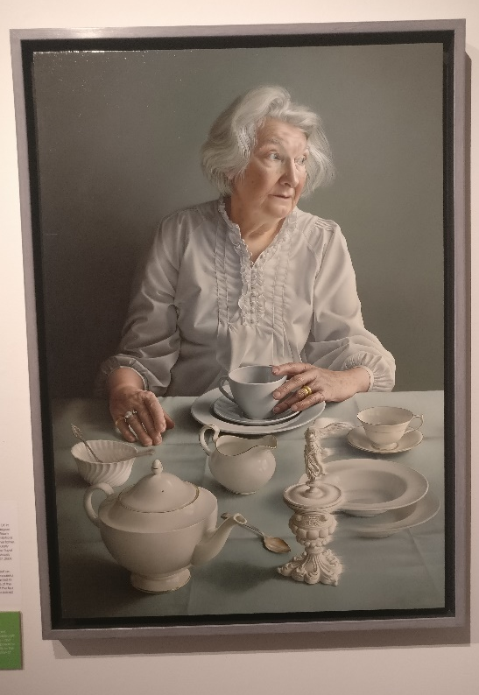
[General analysis/review of my favourite pieces from the BP Portrait Exhibition]
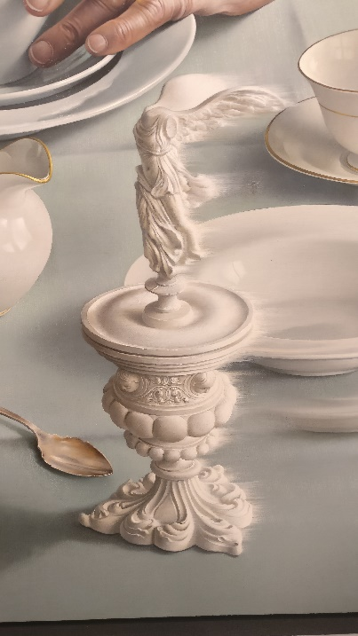
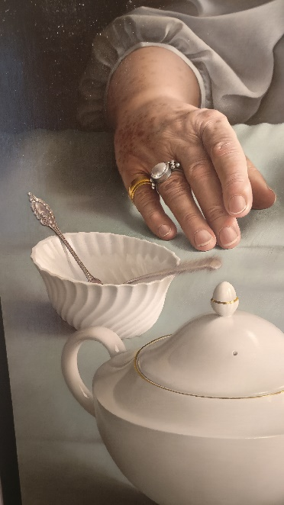
The winning portrait, An Angel at my Table by Miriam Escofet, hangs on the wall directly ahead as you enter the gallery. A large canvas presents the image of a lady with white hair (Escofet’s mother), seated opposite us at a table and glancing off sideways. It is as if we too are sat at the table, looking at the teacups and plates laid out on the table. The whole piece is rendered to an almost photographic quality, but has the personal touch of a paintbrush, imbued with earnestness that can only be conveyed to such an extent through an artist’s work. It’s a poignant piece for me already – the traditional cream gold-rimmed tea-set is very similar to the one we have, evoking memories of shared afternoon teas with my family and grandparents. The distant expression on her mother’s face is rather unusual in the context of the rest of the gallery, as it is truly difficult to discern a particular emotion from the expression. However, other elements of the piece are laid before us, combining to create an overall feeling – of stillness, cold distance, but beneath that, warmth and treasured memories. You can see this in the placing of her hands, rings on both to indicate further story, with one hand tentatively touching the teacup and the other lightly stroking the tablecloth. As an overall piece it is captivating to look at, and the solemn tone gives a sense of captured memory, a beautiful moment portrayed with sincerity and raw truthfulness.

Although, upon closer inspection, further elements of the piece are revealed and it slowly becomes more interesting. What struck me is how the teacup, saucer and plate are stacked in front of her on the table. They are a blueish grey tone, and a different style to the rest of the crockery (cream gold-rimmed) which for me is unusual for a traditional tea. There are two spoons in the sugar bowl, one of which seems blurred as if moving or flickering. An item that seems rather out of place on the table is a small china statue of the Winged Samothrace Nike (goddess of Victory), which also has a slight blur to one side as if flying onto the table. Even after looking carefully at this portrait many times, it wasn’t until recently that I noticed the plate to the right has a blurred repetition beneath it, as if seeing double. These deeper layers of detail create a further connection with us, as we discover more within than those who just take the painting at surface value.
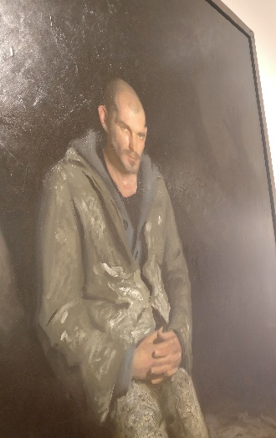
Then, more questions are raised… why is she wearing a nightdress at the table… and why is there no food on the plates, or tea in the teacups? It feels like an echo, a memory we have been placed in as part of the scene, sat at the table. Yet it is only after studying the details that we see the abnormalities, something slightly supernatural that gives it an edge – and yet it still remains a poignant, beautiful piece. This piece encompasses multiple themes from the rest of the exhibition, and has such scope for ambiguity of meaning that the overall tone sits somewhere between peacefulness and restlessness, familiarity and distance, contentment and despondency. It creates a balance in which both extremes exist at the same time, wherein the viewer can find their own interpretation and associations. See for yourself and discover what you may spot that I haven’t – perhaps there are more hidden details that may take another few times of studying before they are spotted.
Broken Bodies by Jamie Coreth depicts a soldier in the dark, an eerie cracked sculpture of a man rising up behind him as if a representation of PTSD and haunting memories left with him.

The Oolographer (in his study) by J.J. Delvine is a self-portrait of Delvine at his desk, with various items such as eggs for painting on (= Oology), and many pictures of old masters’ paintings stuck around him on the wall. These give a further impression of his character and interests, extending beyond the subject himself, along with the subtle dark reflection in the wall, demonstrating his painting skill, with precision and attention to detail.

Mark Lawrence’s Mr & Mrs Cooper, separated cleverly depicts a couple, looking somewhat weather-beaten and guarded, staring directly towards the viewer – each from their individual canvas. They hang on the wall with a small gap between the two canvases, quite literally separated, yet Mr Cooper’s arm remains around his wife on her side (the right canvas), while Mrs Cooper’s elbow can be seen in the bottom corner of the left canvas.

Dad’s Last Day by Nathan Ford is one of the smallest pictures in the exhibition. It looks almost like a child’s drawing, with rough scribbles and block colours on a beige background – but this is what makes it so poignant. ‘Get well soon’ cards line the mantelpiece, and a clock with a scribble instead of hands shows time standing still. Ford’s father is vividly drawn with just a few lines and highlights, giving a visceral depiction of his suffering while the rest of the room fades away with him. My mum, who used to be a nurse, commented that the image is a very accurate representation of what it is like when someone passes away. It’s incredible how such emotion can be evoked from so few lines carefully scrawled on a small page.

